# Console and Cloud Shell

## Task 3: Create a bucket using the Cloud Console

Input:

gsutil mb gs:// qwiklabs-gcp-00-95e2f5a3a100

Output:

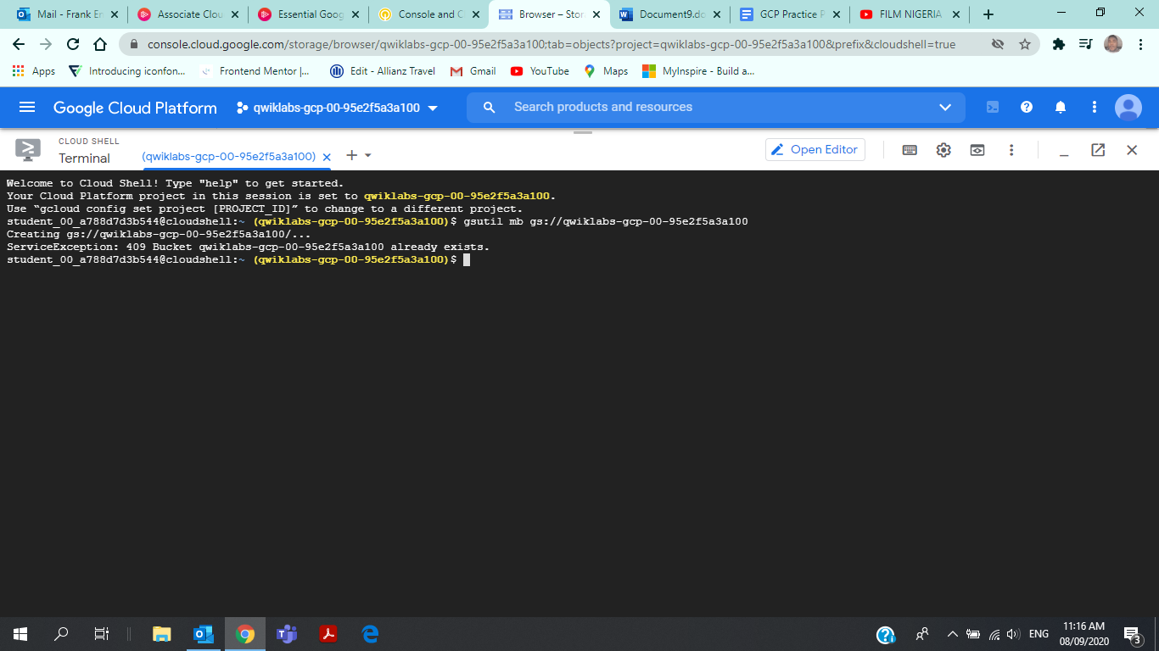

## Task 4: Explore more Cloud Shell features

### Upload a file

Input:

gsutil cp dframe.xlsx gs://qwiklabs-gcp-00-95e2f5a3a100

Output:

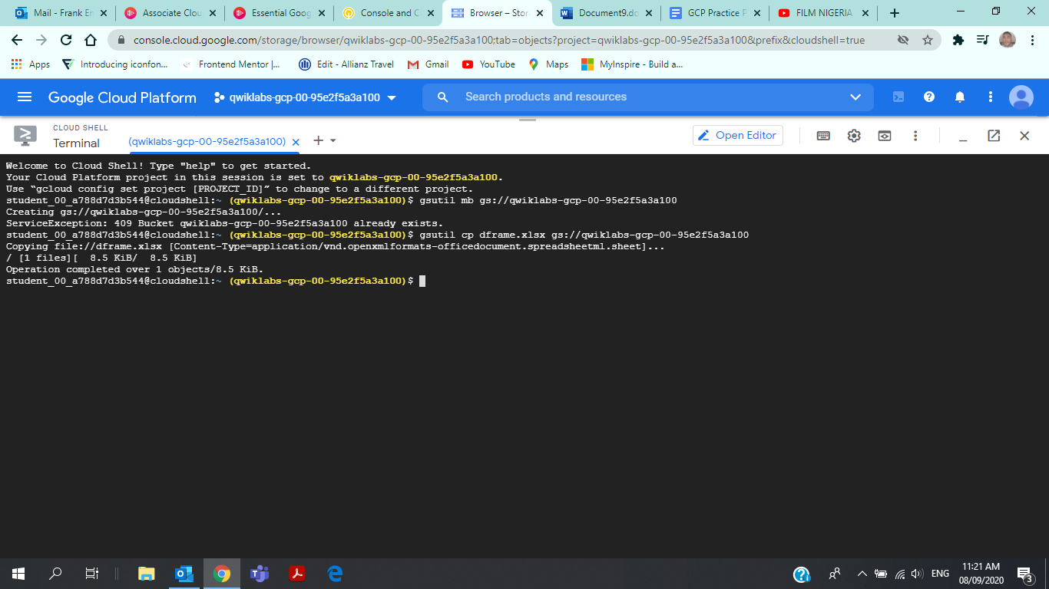

## Task 5: Create a persistent state in Cloud Shell

### Identify available regions

Input:

gcloud compute regions list

Output:

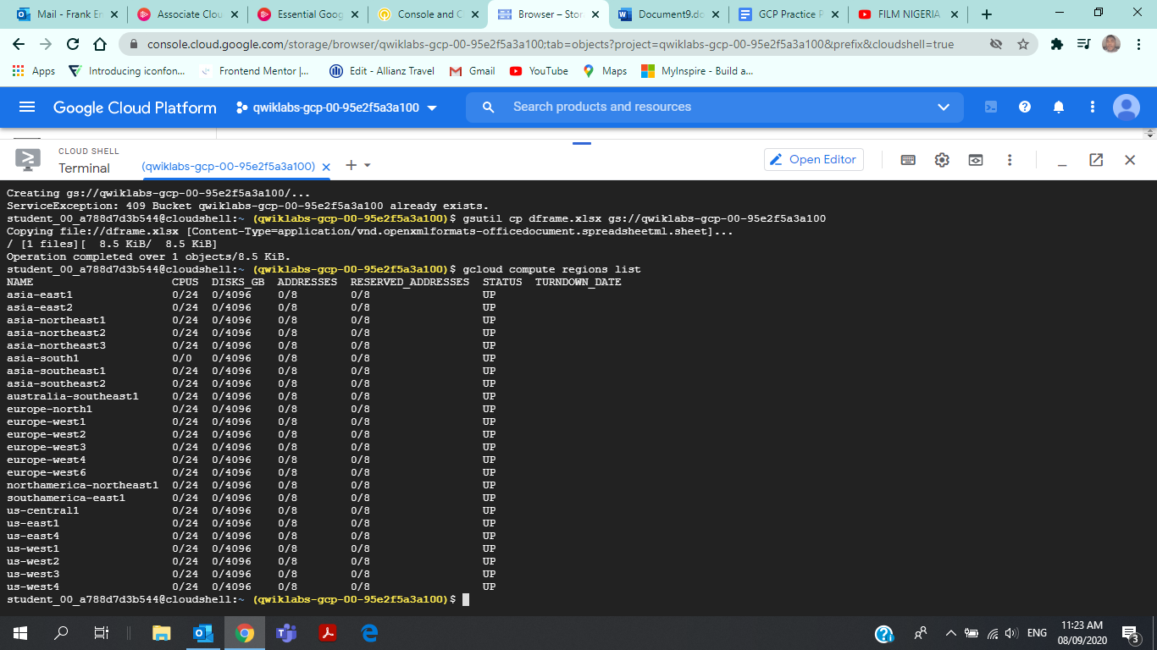

* Selecting region regions

Input:

INFRACLASS_REGION=us-central1

Output:

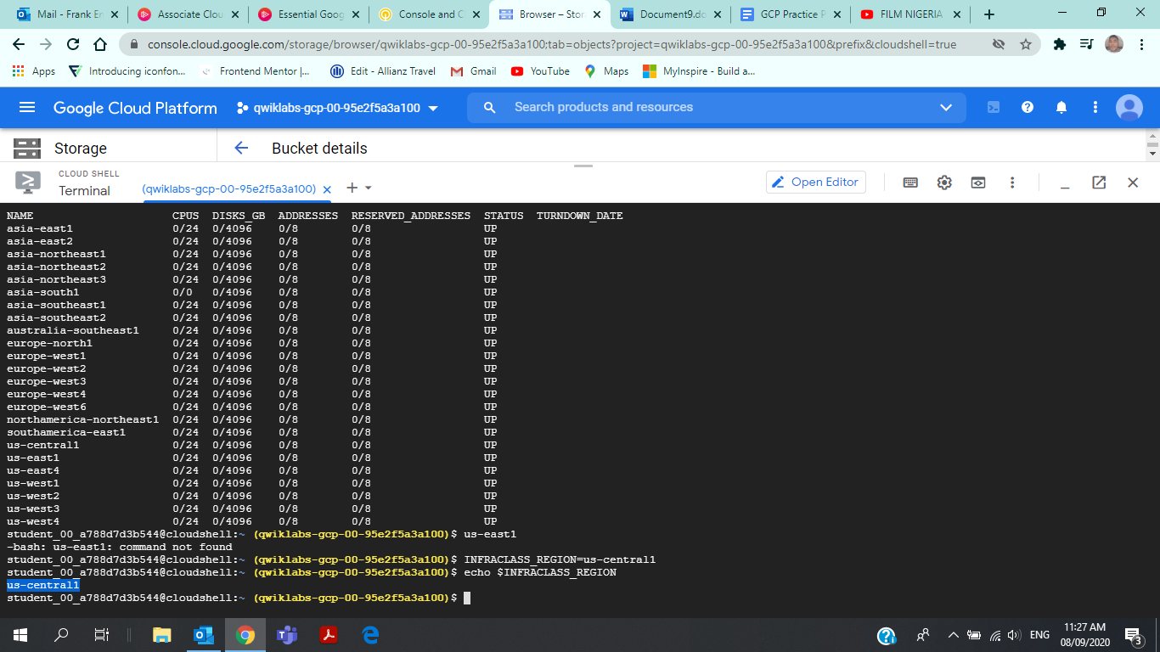

### Append the environment variable to a file

Input:

student_00_a788d7d3b544@cloudshell:~ (qwiklabs-gcp-00-95e2f5a3a100)$ mkdir infraclassstudent_00_a788d7d3b544@cloudshell:~ (qwiklabs-gcp-00-95e2f5a3a100)$ touch infraclass/configstudent_00_a788d7d3b544@cloudshell:~ (qwiklabs-gcp-00-95e2f5a3a100)$ echo INFRACLASS_REGION=$INFRACLASS_REGION >> ~/infraclass/configstudent_00_a788d7d3b544@cloudshell:~ (qwiklabs-gcp-00-95e2f5a3a100)$ INFRACLASS_PROJECT_ID=qwiklabs-gcp-00-95e2f5a3a100student_00_a788d7d3b544@cloudshell:~ (qwiklabs-gcp-00-95e2f5a3a100)$ echo INFRACLASS_PROJECT_ID=$INFRACLASS_PROJECT_ID >> ~/infraclass/configstudent_00_a788d7d3b544@cloudshell:~ (qwiklabs-gcp-00-95e2f5a3a100)$ source infraclass/configstudent_00_a788d7d3b544@cloudshell:~ (qwiklabs-gcp-00-95e2f5a3a100)$ echo $INFRACLASS_PROJECT_ID

student_00_a788d7d3b544@cloudshell:~ (qwiklabs-gcp-00-95e2f5a3a100)$ echo $INFRACLASS_PROJECT_ID

### Output

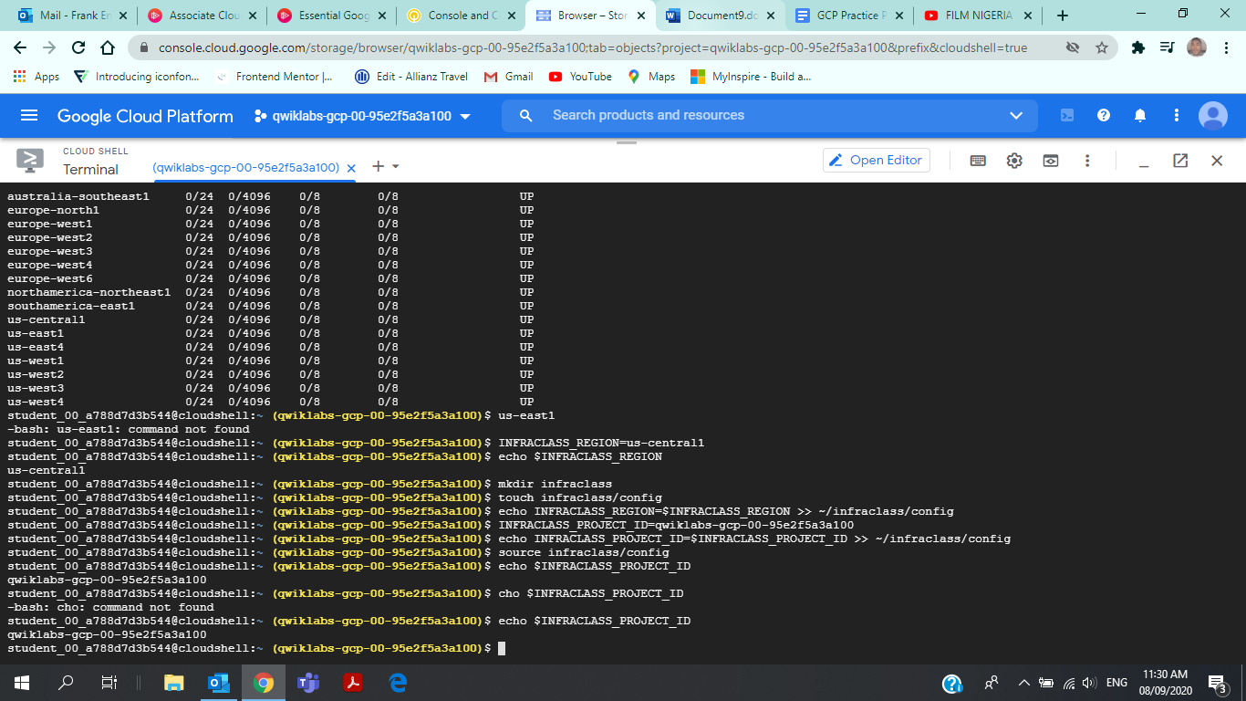

### Modify the bash profile and create persistence

Input:

student_00_a788d7d3b544@cloudshell:~ (qwiklabs-gcp-00-95e2f5a3a100)$ nano .profilestudent_00_a788d7d3b544@cloudshell:~ (qwiklabs-gcp-00-95e2f5a3a100)$ echo $INFRACLASS_PROJECT_ID

Output:

